# Voice technique and control – SYNCOPATION – Mel Wilkerson

**First and foremost**: I recommend anyone who is looking to improve their performance, attend a caller school or weekend workshops where the focus is on performance delivery, singing and patter delivery and voice.

Second: I recommend anyone looking to be a performance artist, (square dance caller) find a good voice coach and get some lessons.

**Syncopation**: I was asked about it and would like to first state, that I am not a master by any means. What I was asked about was how it works and why it works which is difficult to do in writing, but a lot easier to explain when you hear and experience it.

Syncopation, and its use in performance, is a powerful tool and necessary for any would be caller to become a good if not a great caller.

That said, here is my basic understanding of the methodology so that when you do get to learn and apply it, and get mentored on it by people like Wade Driver, Buddy Weaver, Tony Oxendine, Ken Rittuci, Paul Adams, Tim Crawford and others that likely know more about this than I ever will, you may be able to understand the methodology a little easier.

Syncopation is a musical term relating to “emphasis on the off-beat”. Done well it is a powerful tool. Done poorly it is a cacophony of **YECCHHH**!!!!.

How it works is; that if a bar of music is divided into strong, equal beats, syncopation puts the accent midway between two strong beats thus shifting the normal beat accent by stressing or vocally forcing the stress onto the unaccented music beats. – Some people call it counterpoint but in square dancing it is so much more.

The best example is found in Jazz when the band leader counts at the start bringing the band in to begin the music. He/she will count them in with “ah-one, ah-two, ah-one, two, three, four” or “One –and-a - Two and-a…”

In those examples, Syncopation puts the emphasis on the “AH” or the “AND-A” which represent the off-beats. It is what makes the jazz “hot” and the blues “cool. It is what makes many of those country singers like Willie Nelson always seem to sing off the tune but right on the music. It is what makes gospel and harmony so beautiful to listen to.

For square dancing it can add to the rhythm of the patter, enhance the delivery of individual movements to stress or pull them together in an “off-beat” delivery so the dancers can move on the 2/4 or 4/4 timing.

* In short you can say right and left thru as a single phrase all together rather than Right......and.......left.........thru which is how it would be delivered if the musical phrasing was followed.

You have all heard callers that try to sing the calls (especially in singing calls) and you have all felt just how awkward that is to dance to.

The beauty of syncopation is in the science of syncopation, and relative understanding of the effects it can have on dancers. We should all be familiar with the well-known power of music to tap into brain circuits controlling emotion and movement, to actually control the brain circuitry of sensory perception.

* 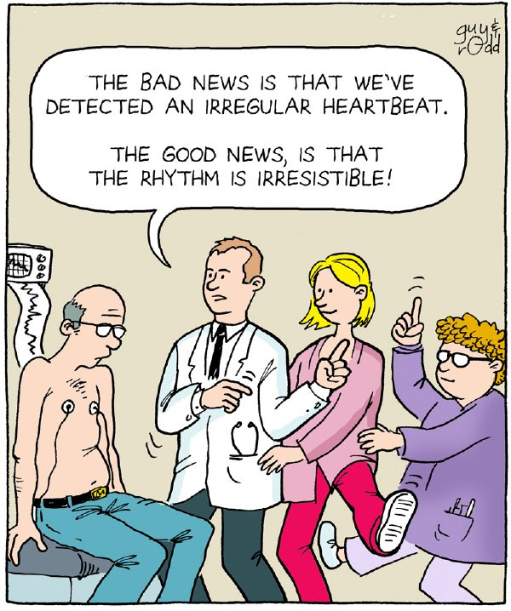This is that feeling you get when you hear a song and automatically start tapping your feet, or swaying to the music.
* This explain how drums unite tribes in ceremony
* Why armies march to bugle and drum into battle,
* Why worship and ceremonies are infused by song,
* Why speech is rhythmic, punctuated by rhythms of emphasis on particular syllables and words, and
* Most importantly how and why we dance in tune with the music.

In music, syncopation involves a variety of rhythms which are, in some way, unexpected which make part or all of a tune or piece of music “off-beat”. More simply, syncopation is a general term for "a disturbance or interruption of the regular flow of rhythm": a "placement of rhythmic stresses or accents where they wouldn't normally occur." The correlation of at least two sets of time intervals. Also known as an "Uneven movement from bar to bar".

Syncopation is used in many musical styles, especially dance music. "All dance music makes use of syncopation and it's often a vital element that helps tie the whole track together". In the form of a back beat, syncopation is used in virtually all contemporary popular music.

Syncopation can also occur when a strong harmony is placed on a weak beat, for instance when a 7th-chord is placed on the second beat of 3/4 (waltz or polka) bar or a dominant is placed at the fourth beat of a 4/ 4 or on the first of 2/4 bar.

* Emphasis on the fourth by stress or even omission to draw attention to it.

In square dancing, the Syncopation refers to the “off beat” delivery of the calls (and sometimes the lyrics of the song) to ensure that the dancers get the music to dance to. Many callers label this as giving the first beat to the dancers rather than taking it for themselves.

An increased benefit of syncopation comes with regard to memory and understanding and ultimately reacting in time with the music. This is where the power of syncopation comes into play.

Studies from the University of Singapore first tested subjects by flashing a series of images on a video monitor and asked them to quickly identify when an image was flipped upside down. While participants focused on this task, a synthetic drumbeat gently tapped out a simple four-beat rhythm in the background, syncopated by skipping the fourth beat of each measure. (Tapping and stressing the off-beat in this case, syncopation by skipping the fourth beat). The participants were able to remember, identify and react to the syncopated beat as it reinforced the mental acuity and ability to identify and react.

What this means for square dancing is that our perception of the external world entering our mind through our eyes (the dancers moving in the square and how we fit in) is affected by the rhythm of what we hear and similarly our ability to understand and react to that is enhanced accordingly. (Performing the call when we hear it and reacting in time with the music)

Syncopation can increase this acuity because something seen to at a point precisely in beat with an auditory rhythm is more likely to be perceived than if it appears out of synch with the rhythm. However, syncopation will draw the attention to the item on the off-beat and the action will be done at the point precisely in beat with the auditory rhythm. Many performance callers refer to this as “Giving the dancer the first beat” - A good example is the delivery of sides face grand square in a singing call. The command is delivered and stressed in the off-beat (attention drawn and understood more clearly) and reinforced by the auditory rhythm and action when the dancers all simultaneously react to the first beat in time with the music.

The recognition on the off-beat (syncopated command), marries with the visual perception of the dancers, and action is virtually instantaneous.

This is why the auditory rhythm does not require a prolonged meditation on the rhythm to cause the person to enter into some sort of a trance-like state. “Within a few measures of music your brain waves start to get in synch with the rhythm. The music starts, your pick up the beat in your mind and your body begins to move to it. The caller gives you the beat so that your foot falls on the first beat and he syncopates much of his/her commands to deliver the moves thus ensuring you are on the beat of the music with your dancing.

It is an automatic process for the dancers. It is a master level skill to achieve for most callers. I hope that has helped at least one of you to better understand the importance of syncopation in square dance calling.

